**EXPERIMENT 4: Calculating Correlation Coefficient**

**Date : 05/1/2019**

**AIM:**

To compute the correlation coefficient of a given continuous time signal by simulation.

**THEORY:**

Calculate the correlation coefficient using the formula:

$$ρ=\frac{1}{\sqrt{E_{x}E_{y}}}\int_{t_{2}}^{t_{1}}{x\left(t\right)y\left(t\right)ⅆt}$$

Where Ex and Ey are the energies of the signal x(t) and y(t) respectively. Ex can be calculated by:

$$E_{x}=\int_{t}{x^{2}\left(t\right)ⅆt}$$

**FLOWCHART/ALGORITHM:**

* Define and plot x(t) and all the other functions for which correlation coefficient is required.
* Define a function to calculate energy of a given signal waveform
* Define a function to calculate correlation coefficient of two signals using the energy function defined previously.
* Use the command inttrap(t,x) for integration.
* Taking x(t) and g(t) as attributes ouput the correlation coefficient using the function

**PROGRAM:**

*//-----------------------------START--------------------------------------------*

t = 0:0.1:5

x = ones(1,length(t))

g1 = ones(1,length(t))

function [**E**]=energy(**t**, **x**)*//Function for calculation of energy*

**E** = inttrap(**t**,**x**.^2)

endfunction

function [**P**]=integrate_functions(**t**, **x**, **g**)*//Function for finding the integration*

**P** = inttrap(**t**,**x**.\***g**) *// of x(t)*g(t)*

endfunction

*//-----------------------------------------*

subplot(331)

plot(t,x)*//Plotting signal*

xlabel('time')

ylabel('x(t)')

*//-----------------------------------------*

subplot(332)

plot(t,g1)*//Plotting signal g1*

xlabel('time')

ylabel('g1(t)')

Ex = energy(t,x).^0.5

Eg1 = energy(t,g1).^0.5

integ = integrate_functions(t,x,g1)

output = integ/(Ex*Eg1)

disp(output)

*//-----------------------------------------*

g2 = ones(1,length(t)).*0.5

subplot(333)

plot(t,g2)*//Plotting signal g2*

xlabel('time')

ylabel('g2(t)')

Eg2 = energy(t,g2).^0.5

integ1 = integrate_functions(t,x,g2)

output1 = integ1/(Ex*Eg2)

disp(output1)

*//-----------------------------------------*

g3 = ones(1,length(t))*-1

subplot(334)

plot(t,g3)*//Plotting signal g3*

xlabel('time')

ylabel('g3(t)')

Eg3 = energy(t,g3).^0.5

integ2 = integrate_functions(t,x,g3)

output2 = integ2/(Ex*Eg3)

disp(output2)

*//-----------------------------------------*

t1 = t.*-.2

g4 = exp(t1)

subplot(335)

plot(t,g4)*//Plotting signal g4*

xlabel('time')

ylabel('g4(t)')

Eg4 = energy(t,g4).^0.5

integ3 = integrate_functions(t,x,g4)

output3 = integ3/(Ex*Eg4)

disp(output3)

*//-----------------------------------------*

g5 = exp(-t)

subplot(336)

plot(t,g5)*//Plotting signal g5*

xlabel('time')

ylabel('g5(t)')

Eg5 = energy(t,g5).^0.5

integ4 = integrate_functions(t,x,g5)

output4 = integ4/(Ex*Eg5)

disp(output4)

*//-----------------------------------------*

g6 = sin(2*%pi*t)

subplot(337)

plot(t,g6)*//Plotting signal g6*

xlabel('time')

ylabel('g6(t)')

Eg6 = energy(t,g6).^0.5

integ5 = integrate_functions(t,x,g6)

output5 = integ5/(Ex*Eg6)

disp(output5)

*//------------------------------------END---------------------------------------*

**RESULT:**

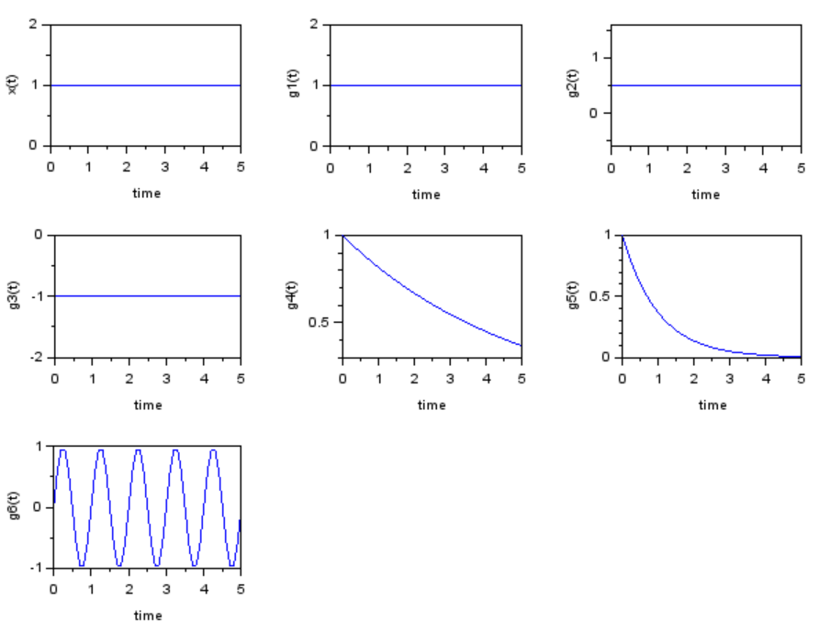

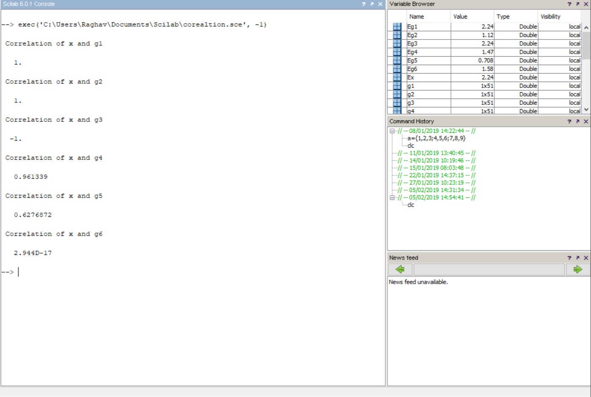

**CONCLUSION:** Correlation coefficient of various simulated signals was successfully calculated.